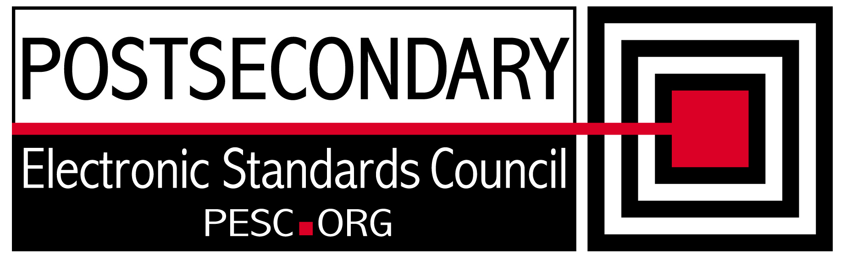

Standards Forum for Education
Status Update Form

Workgroup/Board Group Name | Technical Advisory Board
General Summary of Status | Working on NIEM conformance and domain establishment recommendation
Status Flag (Red/Yellow/Green) | Green
Report Data | 8/10/2012
Projected Completion Date | Standing PESC Board

Item | Responsible Resource | Status  (Report update status of Deliverable/Objective  since last report)
Planned Deliverables/Objectives
(Provide at least 3)
Automated Implementation Guide | Morris/TAB | On hold while working on NIEM recommednation
NIEM Evaluation | TAB/David Webber | Developing recommendation and implementation schedule for the PESC Board
XML R&R | Morris/Sue Lou (FSA) | Definition of elements will then be put in the batch import workbook for R&R. Waiting for definitions from the CCB
Guideline for XML Architecture and Data Modeling revision | TAB | On hold until NIEM alignment determined
Accomplishments/
Completions
NIEM Evaluation | Webber/Morris | Completed a draft recommendation describing the technical feasibility and the steps needed for establishing an Education Domain for NIEM.
Issues/Obstacles
Meetings/Calls Since Last Update | 4

Note: Chairs and/or leaders of workgroups, boards and committees under The Standards Forum for Education are required to provide updates during the Steering Committee’s monthly conference call meeting held the second Friday each month at 2:00pm EST. Call in information is: 866-352-3799 *7696363*. Forms must be completed and submitted prior to meeting time. Forms may also be posted on the PESC website as needed to provide the community at-large with a means to obtain updates for ongoing, but yet to-be-completed development efforts.

To add rows to table, click outside of the table, to the right on the row where you want to add another row . With cursor blinking, hit the enter key. A new row will be inserted.

